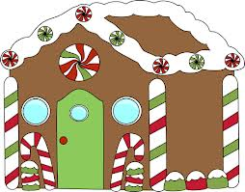
Gingerbread houses!
On Friday December 14, we will be making gingerbread houses with our buddies in the morning (8:45). We are asking for your help to make this day a success!
- Please send a labeled bag of assorted candies with your child on this day. These will be for them to use on their house, not for sharing. We do have a student with a nut allergy, please avoid sending candies with nuts (ie M&M peanut, chocolate covered nuts).
- If you can bring in $1 to help cover the cost of the cookies and icing, that would be greatly appreciated.
- If you are able to help that morning (until about 10:00), please speak with your child’s teacher.

Thank you for your support.

Mrs. Pulvers, Ms. Dickenson, Mrs. Zvi and Mr. McDonald.

